1)
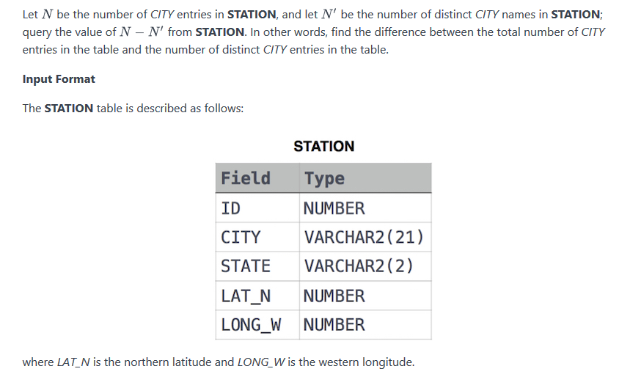

select (count(CITY)-COUNT(DISTINCT CITY)) from STATION;

2)
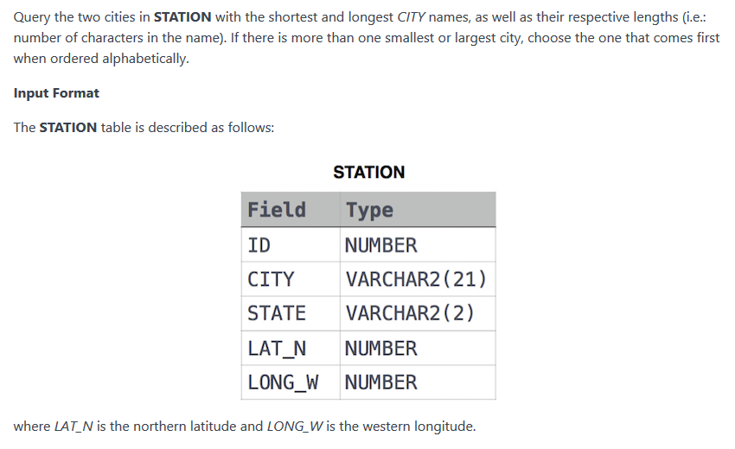
SE HARÍA EN DOS CONSULTAS

SELECT TOP 1 CITY, LEN(CITY) FROM STATION ORDER BY LEN(CITY) ASC,CITY; --El ASC no es necesario porque es así por defecto.

SELECT TOP 1 CITY, LEN(CITY) FROM STATION ORDER BY LEN(CITY) DESC,CITY;

3)
SELECT distinct CITY FROM STATION WHERE CITY LIKE '[aeiou]%[aeiou]';

Para búsquedas no repetidas de ciudades que empiecen y acaben en vocal.

RECUERDA:
- [ ] es un patrón
- % significa cualquier carácter
- ' ' indica cadena de carácteres

4)
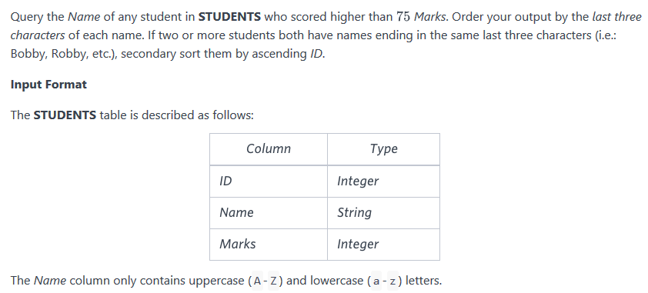
SELECT Name FROM STUDENTS WHERE Marks > 75 ORDER BY RIGHT(Name,3),ID;

5)

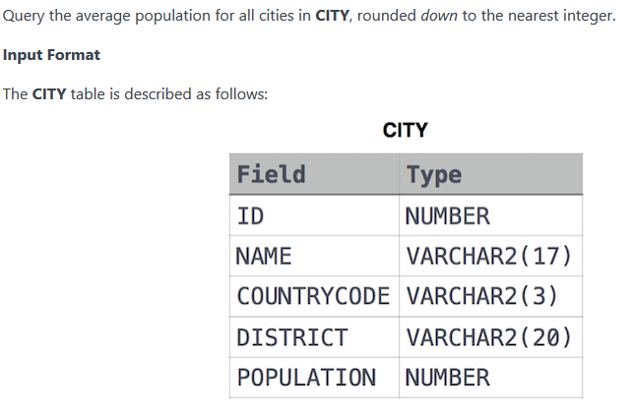

SELECT FLOOR(AVG(POPULATION)) FROM CITY;

